**Rework Instructions for PCA-00001143-001**

**Rev B.**

1. Replace U11 with ICS-00001593 (MPN: [MT29F4G08ABADAWP:D](javascript:displayObject('MfrPartHandler',%20'1483',%20'1014870651',%20'0');) )

**Reason:** Schematic BOM for DVT was correct but the build BOM contained the original part from EVT by mistake.

2. D10 is in upside down. Remove and re-install D10 so green dot is away from pin 1 dot on silkscreen.

**Reason:** Instructions to assembly house were clear but part was put on upside down so battery LED will not light.

3. Replace R8 with 2.15K 1% 0201 resistor

4. Replace R10 with 7.50K 1% 0201 resistor

**Reason:** These values were changed in DVT from EVT and the layout was altered to reduce effect of self-heating during charging of battery, but the self-heating effect is still too great to use resistor values used on build. These new values will allow charging at full current in hot ambient air temperature.

5. Replace R211 with 41.2K 1% 0201 resistor

**Reason:** The new Blue LEDs are brighter than anticipated so the lowest current level setting is being adjusted downward in order to have dimmer LEDs at lowest setting.

6. Rework on circuits for D11-D14.

a) Remove R212

b) Remove D11-D14

c) Perform cuts on PCB traces as shown by red lines on drawings. Note: pin 1 pads of D11-D14 should be isolated from GND after this rework.

d) Re-install D11-D14 as before.

d) Add wires as shown by white lines on drawings. The wires must go from points indicated to pin 1 of LEDs.

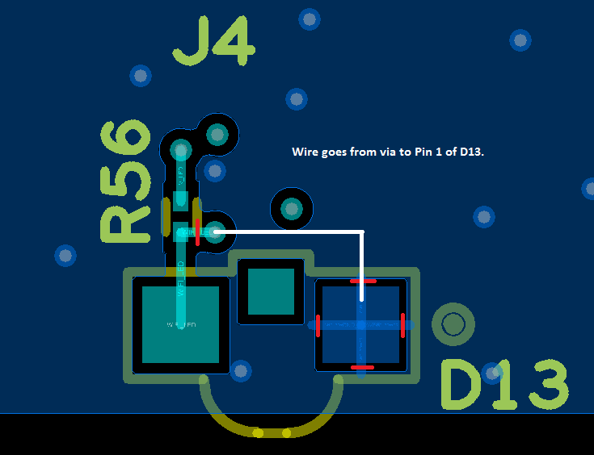

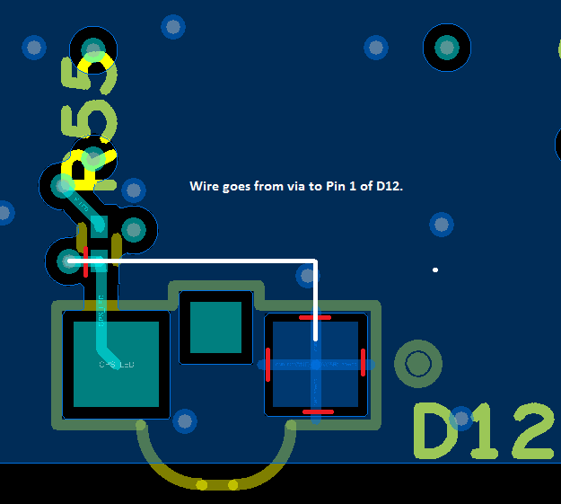

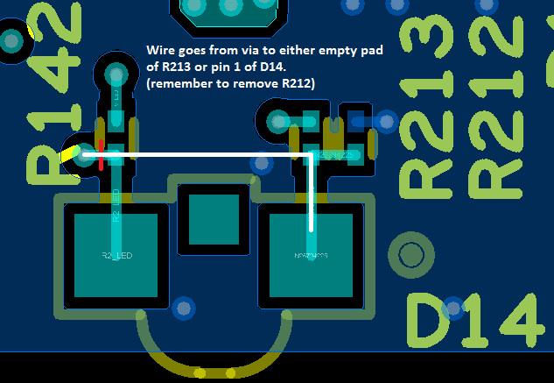

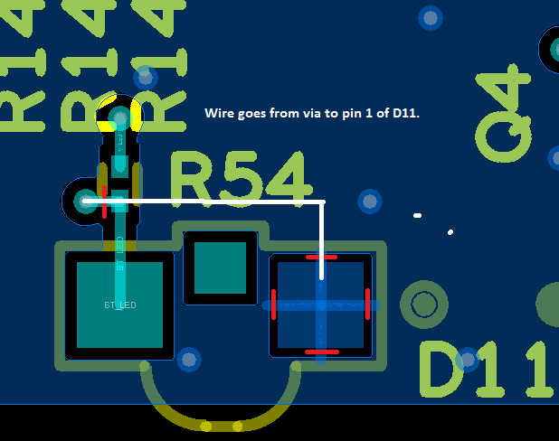

**Reason:** DVT circuit was changed from EVT to accommodate higher voltage drop of blue LEDs by allowing V_LED (voltage supply for LEDS) to go up to 5V instead of just 3.3V. The driver circuits on DVT were changed out of worry about putting this higher voltage into digital driver outputs of CPU which are meant to swing up to 3.3V only. The downside of the DVT scheme is that when LEDs are off, the digital drivers will sink even more current than when the LEDs are on. During testing of DVT this was deemed too much power to waste. Secondly, it was determined that the original EVT circuit will work after all, and does not have the cost of extra power when the LED is off. The original EVT circuit when operated in push-pull mode, not open-drain mode, will work because when the driver is at 3.3V and V_LED is at 5V the conduction of current through the LED is very small because the voltage drop is only 1.7V. Full turn on for this LED is closer to 2.6V. This small amount of current will flow into the output driver FET and into the VCC supply on the CPU. But this current is too small worry about. So the plan is to rework the DVT circuit to be same topology as EVT and then change the mode of the driver to be push-pull instead of open-drain.

DVT circuit:

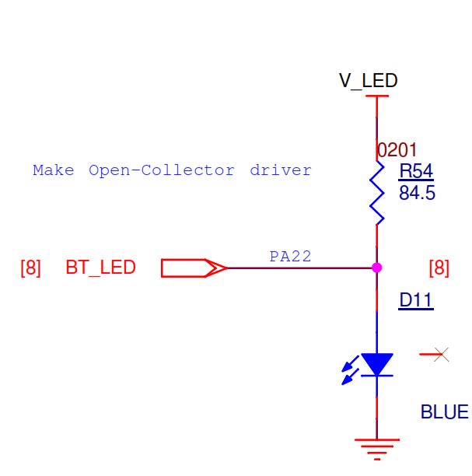

This circuit only drives low to turn off LED but wastes this power, and then floats high to the drop across LED when LED is on. (2.6V to 3.1V max)

EVT circuit:

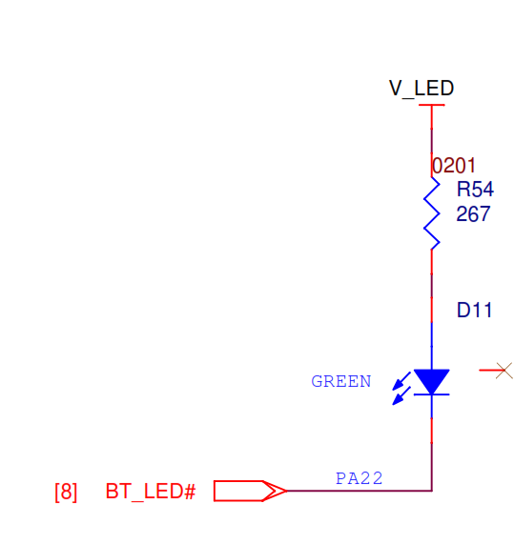

New DVT circuit looks like this EVT circuit but will drive both high and low.